Health and Sanitation Plan Template

Name of ECI____________________________________________________________________________

Located at____________________________________________

Name of Operator_____________________________________

Telephone contact: Mobile____________, Home____________

1. INTRODUCTION

_____________________________________________________________________________________________________________________________________________________________________________________________________________________________________________________________________________________________________________________________________________________________________________________________________________________________________________________________________________________

1.1 Purpose of plan
The name of the plan will be the _____________________________________Plan. It provides the guidance that ensures that all early childhood institutions provide a safe and healthy environment for children. The purpose of the plan will be to:

_____________________________________________________________________________________________________________________________________________________________________________________________________________________________________________________________________________________________________________________________________________________________________________________________________________________________________________________________________________________

  - Objectives of the Plan

______________________________________________________________________________________________________________________________________________________________________________________________________________________________________________________________________________________________________________________________________________________________________________________________________________________________________________________________________________________________________________________________________________________________________________________________________________________________________________________________________________________________________________________________________________________________________________________________________________________________________________________________________________________________________________________________________________________________________________________________________________________________________________________

1.3 Scope of Plan

________________________________________________________________________________________________________________________________________________________________________________________________________________________________________________________________________________________________________________________________________________________________________________________________________________________________________________________________________________________________________________________________________________________________________________

PART A - HEALTH PLAN
1.1 Employee’s Health

For employment and continuation of employment all employees, the operator and any other person performing duties in this early childhood institution shall:

- Be medically certified by a registered Medical Practitioner on an annual basis. The employee should not be suffering from any physical handicap or mental health disorder that would interfere with the person’s ability to perform assigned duties adequately.

- Have a valid Food Handler’s Permit.

- The Employees Health Form shall be completed and update annually).

Employees Health Form

Employees Health

Employee name | Position | Medical Certificate |  | Food Handlers Permit
Employee name | Position | Issue date | Renewal date | Issue date | Renewal date

2 Children’s Health

The Child’s Health Record will form part of records kept for each child.

Prior to the acceptance of any child or infant to this Early Childhood Institution, the operator shall:

  - Ensure that he/she receives a medical report completed by a duly qualified medical practitioner (See Appendix II).

  - The ECI operator will ensure that each child is appropriately immunized for age as per Ministry of Health Immunization schedule as outlined below. A copy of each child’s updated Immunization Card will form part of the record at the Early Childhood Institution

MINISTRY OF HEALTH - JAMAICA

IMMUNIZATION SCHEDULE

VACCINE* | Obligatory (answer Yes/No) |  | Number of Doses | Age at first Dose | Interval between doses | Booster (if any)
VACCINE* | Compulsory  by Law? | Required for school entry? | Number of Doses | Age at first Dose | Interval between doses | Number | Age (s)
BCG | Yes | Yes | 1 | Birth – 6 weeks | N/A | N/A | N/A
DPT | Yes | Yes | 3 | 6 weeks | 6-8 weeks | 2 | 18 mths,  4-6 yrs
POLIO | Yes | Yes | 3 | 6 weeks | 6-8 weeks | 2 | 18 mths,  4-6 yrs
MMR | Yes | Yes | 1 | 12 months | -------- | 1 | 4-6 yrs
HEP B | Yes | By 2006 | 3 | 6 weeks | 6 weeks for dose 2,  12 weeks for dose 3 | N/A | N/A
H. FLU (Hib) | Yes | By 2006 | 3 | 6 weeks | 6-8 weeks | N/A | N/A

  - The child’s Immunization Card will be inspected for authenticity including the dates of vaccine administration.
  - Each Child’s Immunization card will be reviewed every six months in the first year of life and yearly thereafter. The updated information will be transferred to the child’s file, that is, a copy of the updated Immunization Card. The immunization record will be available for reviewed at any time by Public Health Officers.

2.3 Special Medical Requirements

Provisions will be made for Special Medical Requirements which may include but are not limited to:
- Chronic Medical Illnesses including
    - Asthma
    - Epilepsy (Fits)
    - Diabetes
    - Psychiatric illness
- Physical Disabilities example blindness, paraplegia and amputation
- Mental Disabilities such as mental retardation

The Special Medical Requirement will be documented for each on cumulative form as outlined below and will include the management plan as delineated by the child’s medical practitioner. That is:

  - Medication type, dosage and frequency of administration
  - Special care requirement such as support or change of positioning

The management plan will be known to all caregivers especially those in direct contact with the child. Any changes in the management plan should be notified in writing to the institution.

Special Medical Requirements

Child’s Name | Age | Caregiver/Teacher  Name | Chronic Illness Physical/Mental disability | Management Plan

2.4 Allergies

An allergen log, as illustrated below will be kept of all known allergies. This log will be posted at __________ ______________________________________________________. The caregivers will be advised of a course of action to follow in the event of accidental contact or ingestion. Caregivers involved in either the preparation of food or serving of commercially packaged foods will be informed so that known allergens are excluded.
Allergen Log

Child’s Name | Age | Caregiver/Teacher  Name | Allergen | Substitute Where Applicable

If a previously unknown allergy is discovered, it will be recorded (See Illness Log) and parents or guardian notified. In the event of severe allergic reaction the Emergency Medical Plan will be activated.

2.5 Special Dietary Needs

Where a child has special dietary needs/requirements, the operator will ask parents to supply a sample menu or provide meals for the duration of the child’s stay at the institution. The information will also be logged in the Special Dietary needs/requirements log illustrated below.

Child’s Name | Age | Caregiver/Teacher  Name | Special Dietary Needs | Management Plan

3. Medication Procedures

Medication will be administered in this institution under the following conditions:
- Prescribed for acute or chronic condition by a Medical Practitioner
- Non prescription for emergency use or upon parental written request

The following parameters will guide the administration of medication:

3.1 Parental Medical Authorization as outlined in the form below will be required for the administration of all drugs to children whether prescription or non-prescription. This will be required for each period of illness or every six months for chronic illnesses.

Specific Parental Medication Authorization Form
(To be completed per illness or every 6 months where applicable)

Name of Child ___________________________________________________________
Date of Birth __________________ Age: ______________

Name of  Medication | Expiry Date | Dose | Time to be Given | *Method of Administration | Duration
________________
________________

________________
________________

________________
________________

________________
________________

* How it is to be given example by mouth, inhale, inhale using spacer drops to nose or mouth

Special Considerations: ____________________________________________________

________________________________________________________________________

________________________________________________________________________

To the Parent/Guardian
- All medication must:
- Be in the original container
- Over-the-counter medication must be kept in the originally labeled container and be labeled with the child's first and last name.
- Prescription medications must contain the original pharmacy label

- For long-term medication the authorization must be renewed at least once every six months.
- Any changes in the original medication authorization shall require the completion of a new authorization form.

Name of Parent: ____________________________

Signature of Parent: _________________________ Date: _____________

3.2 Medication will only be dispensed from its original container labelled with the child's name.

3.3 A Medication Log illustrated below will be maintained for all medications dispensed to children by personnel at the institution.

Medication Log

Child’s Name | Date | Time | Name of medication | Amt. of Medication | Noticeable Adverse Reaction | Signature

3.4 Storage of Medication: All medications will be
  - Kept in a locked storage cabinet or container which is not accessible to the children
  - Stored separate from chemicals or poisons.
  - Medications requiring refrigeration shall be placed in a leak proof container in a refrigerator that is not accessible to the children.

3.5 Unused Medication will be returned to the child's parents daily.

  - Non-emergency injections the most common being insulin for diabetes shall be preferably given by the parents but where this is not possible then designated suitable trained personnel should administer the same

4. Record Keeping / Registers

4.1 Illness Register/Log (Appendix XI)

This Early Childhood Institution will establish and maintain a permanent log which will be available to be audited at any time by Public Health Officers or by Inspectors designated by the Early Childhood Commission. This register will contain both illnesses manifested in the child during care as well as illnesses that caused an absence.

1. Name of person affected: _____________________________________ Age: ______ Gender: _____
2. Date of Illness: ______________________________________ 4. Time of Illness: __________________
3. Description of symptoms
________________________________________________________________________________________________
5. Description of signs:
______________________________________________________________________________________
6. Actions Taken/Response of Staff
_________________________________________________________________________________________________
7. Name of Person Notified:
8. Referral
Referred by:______________________________ |  | Referred to:_________________________________________
9. Medical Practitioner’s Diagnosis
______________________________________________________________________________________
10. Form Completed by:

Name:___________________________________Signature_____________________________Date________________

4.2 Injury Report Log (Appendix XII)

An injury report log (See Appendix XII) will be established and maintained by the institution. When an injury occurs at this Early Childhood Institution, the first course of action will be to administer first aid and if necessary medical attention will be sought. The report will be completed in triplicates and distributed as follows
- One copy to the Parent or Guardian in the case of a child. If the injured individual is an adult then he/she will be given a copy. If the person is not in a condition to receive the copy then the appointed person will be given this copy.
- One copy will be placed on the Child’s File or the individual’s personnel file.
- One copy will be filed in chronological order in the Early Childhood Institution Log. This shall be kept for a period of not less than seven years from the date of recording. This log may be audited at any time by Public Health Officers or by Inspectors designated the Early Childhood Commission.

The following information will be recorded in the injury log:

- The name, gender and age of the person injured;
- The date and time of the injury;
- The location where the injury occurred;
- A description of the circumstances leading to the injury;
- A description of the nature of the injury;
- If the injured person is a child, the name of the employee responsible for the care of the child at the time the injury occurred;
- The action taken to treat the injury, including the name of the person who treated the injury;
- The name of the person completing the report; and
- The name and address of the institution.

5. Communicable Disease Prevention and Control

5.1 Universal Precautions against blood borne illnesses

The operator will ensure that:
- all care givers are knowledgeable about Universal Precautions
- all care givers are encouraged to have complete Hepatitis B Immunization
- all care givers are provided with personal protective equipment/gears
- contaminated waste is appropriately disposed of so that it is inaccessible to others including children.
- proper hand washing procedure is practiced at all times

  - Reporting requirements under the Public Health Act

The Operator will ensure that the Public Health Department in the Parish of _______________________
_________________________________ is notified on the suspicion of the communicable diseases and health events listed below within 24 hours.

Notifiable Conditions | Definition
- Accidental Poisoning | Any case of suspected poisoning (e.g. bleach or kerosene ingestion) considered to have occurred by accident.
- Acute Flaccid Paralysis | Acute (sudden) Flaccid Paralysis in the absence of trauma
- Fever with Rash | Fever (>38 ºC or 101 ºF) and rash
- Tuberculosis | Tuberculosis (TB) is an infectious disease of the lung caused by bacteria whose scientific name is Mycobacterium tuberculosis.
- Meningitis | Meningitis is a potentially fatal inflammation of the meninges, the thin, membranous covering of the brain and the spinal cord. Meningitis is most commonly caused by bacterial, viral, or fungal infection, although it can also be caused by bleeding into the meninges, cancer, diseases of the immune system, and an inflammatory response to certain types of chemotherapy or other chemical agents.
- Encephalitis | Encephalitis is an inflammation of the brain. It may be caused by direct infection of the brain by a virus or bacterium. Inflammation can also occur as a complication of some other disorder, such as mumps or herpes simplex.
- Malaria | Malaria is an infectious disease caused by a parasite (plasmodium) which is transmitted from human to human by the bite of infected female Anopheles mosquitoes.
- Hepatitis B | Hepatitis B is a viral infection of the liver caused by the Hepatitis B virus (HBV)
- Leprosy | Leprosy is a slowly progressing bacterial infection that affects the skin, peripheral nerves in the hands and feet, and mucous membranes of the nose, throat, and eyes. Destruction of the nerve endings causes the the affected areas to lose sensation.
- Rheumatic Fever | An illness that occurs following a streptococcus infection (such as a "strep throat") or scarlet fever and predominantly affects children. Symptoms include fever, pain in the joints, nausea, stomach cramps, and vomiting. Rheumatic fever can cause long-lasting effects in the skin, joints, heart, and brain.
- Tetanus | An often fatal infectious disease caused by the bacteria Clostridium tetani which usually enters the body through a puncture, cut, or open wound. Tetanus is characterized by profoundly painful spasms of muscles, including "locking" of the jaw so that the mouth cannot open (lockjaw)
- Typhoid Fever | An acute illness with fever caused by infection with the Salmonella typhi bacteria contracted from contaminated water and food. The disease has an subtle onset characterized by fever, headache, constipation, malaise and chills.
- Fever with Jaundice
- Outbreak | Outbreaks such as Gastroenteritis, hand-foot and mouth disease, Chicken pox, Conjunctivitis ( Pink Eye), Ring Worm, Scabies, Lice, Colds/ Influenza, Sore throat/ tonsillitis.

The operator, on suspicion of an outbreak will follow the management guidelines outlined in the management of communicable diseases.

  - Management of Communicable Diseases

The operator will ensure that proper and frequent hand washing is practiced to prevent the spread of communicable diseases.

Children who are suspected to be infected with a communicable disease will:
- Be separated from contact with other children at the institution
- Be sent home as soon as possible
- Return to institution only after he/she is certified by a duly qualified medical practitioner to be in good health.

6. Emergency Medical Response

6.1 Consent Form

A Parental Consent Form for Medical Emergency will be completed for each child prior to the first day of admission. ( See Appendix XIII). Upon acceptance of any child for care, the operator will ensure that written consent allowing for emergency medical treatment is obtained. This will form part of the child’s admission record.
This form
- will include emergency contact information for parents/ guardians as well as other individuals designed by them
- will include details of the contact information for the child’s regular health care provider
- provide details of any health condition affecting the child and the necessary emergency measures to be instituted
- give consent for the operator to seek medical attention in case of an emergency in the event that the parent/ designate can not be reached or contacted
- Specifies the acceptance of the administrative arrangements for payment for medical expenses incurred.
- Will be subject annual update or sooner if child is absent/ removed from care for a period of greater than one month.

6.2 Referral Mechanism

The operator will establish a referral mechanism to facilitate the prompt and efficient transfer of an ill child for appropriate medical care. The operator will:
- Identify public and private care providers in close proximity to the institution
- In the case of a public facility, ascertain from the officer in charge the type and level of health care that can be accessed at that particular facility.
- In the case of a private facility, check to ensure that the facility is operated by a duly registered Medical Practitioner
- Have dialogue with the individual in charge of such facility and establish a mechanism for referring an ill person.

In the event that it becomes necessary to access medical care, the operator will
- Ensure the completion of the referral form ( Appendix XIV)
- Designate a senior employee to accompany the ill child
- Arrange appropriate transportation to allow the ill child quick access to care.
- Ensure that the event is recorded in the illness log.

7. STRUCTURAL AND EQUIPMENT REQUIREMENTS

7.1 Basic First Aid Kit

The operator will ensure that the institution is equipped with adequate supply of basic First aid items as designated by the Red Cross First Aid Kit Guidelines listed below:

The contents of the kit will include
- Adhesive strips / band aids
- Adhesive tape
- Eye pads
- Triangular bandages
- Conforming bandages
- Safety pins
- Scissors
- Tweezers
- Thermometer
- Kidney dish
- Disposable gloves
- Gauze squares/ pads
- Alcohol swabs
- Sterile saline eyewash
- Cold pack
- Plastic bags
- Antiseptic ointment
- Reusable ice pack
- Hand cleanser
- Small Flashlight and Extra Batteries
- Blanket
7.2 Maintenance of First Aid Kit (Appendix XV)
The operator will establish the following mechanism to maintain the first Aid Kit.
- Ensure that the contents of the first aid kit are checked at a specified interval each month; this check will include expiration dates, spillage, other degeneration.
- Ensure that such kit(s) are restocked when needed.
- Ensure that the location of the kit is known to all relevant individuals.
- Ensure that the kit is not within reach of the children.
- Ensure that a kit is available for trips away from the Early Childhood Institution.
- A First Aid Kit checklist will be completed on a monthly basis as illustrated on the next page.
Early Childhood Institution
First Aid Kit Checklist
Name of designated employee: ______________________________________ Year:___________.

This first aid kit will be checked on the first working day of each month. Items to be re-stocked must be brought to the attention of the operator by the designated employee.

 | Jan | Feb | Mar | Apr | May | Jun | Jul | Aug | Sep | Oct | Nov | Dec
adhesive strips / band aids
adhesive tape
eye pads
triangular bandages
conforming bandages
safety pins
scissors
tweezers
kidney dish
disposable gloves
gauze squares/ pads
Alcohol swabs
sterile saline eyewash
Cold pack
plastic bags
Antiseptic ointment
reusable ice pack
Hand cleanser
Small Flashlight and Extra Batteries
Blanket

  - Sick Bay

The operator will ensure that a separate room or designated area within a room, be reserved for the care of a child who needs to be spearated due to ilness or injury. The area will be quiet, well ventilated with adequate lighting and afford some degree of privacy for the sick child

  - Suggested Operating Proceedure for Sick Bay

- Employee(s) who are competent to perform such duties will be rostered/assigned for duties. Employees on sick bay duties will not be visually impaired or semi literate.
- Parents/guardians will be Informed of child’s admission to sick bay
- Parent's specific instructions will be obtained, and followed if appropriate, until the child is picked up or is able to return to the child's group.

- A Sick Bay Register (See Appendix XVI) will be established and maintained in which the following will be logged
- Name,
- Date and time ,
- Reason Child admitted
- Treatment Administered
- Medication administered
- How child leaves
- Time child leaves

- Treatment proceedure will be established for each child (e.g. child with fever to have tepid sponge and then fever relief medication, Oral Rehydration Therapy:½ cup of solution every half hour or after every loose stool)
- Record will be made of proceedures carried out and medication administered
- Record will be made of how child leaves sick bay and time of exit ( e.g. collected by parent, transferred to hospital/ health centre)
- A child with a known infectious condition will be kept separate from those who are not infectious.
- Employees will be advised to observe infection control measures , in particular hand washing after contact with each child.
- Separate disposable items ( e.g. cup and spoon) will be kept for each child; these will be discarded appropriately after use.
- Freqeunt change of bed linen after occupancy by a child with an infectious condition will be carried out
- All equipment will be disinfected appropiately

PART B - SANITATION PLAN

SANITATION, & FOOD SAFETY REQUIREMENTS

8.0 Environmental Cleaning

Sanitation within the Early Childhood Institution is of the utmost importance due to the fact that young children are more vulnerable to infections. Consequently; every effort will expended in attaining and maintaining a clean and safe environment

- Walls when soiled, will be washed with detergent, disinfected and air dried. Heavily soiled walls will be repainted, and those within kitchens and restrooms which are tiled will be cleaned and disinfected daily with an approved soap solution and disinfectant. I will ensure that concentrations recommended on the label are followed when disinfecting surfaces.

- Floors will be swept clean to remove all visible soils before applying cleaning/soap solution and sanitizer (disinfectant). Kitchen and restroom floors will be observed and cleaned as required.

- Classroom furniture and equipment, door handles and light switches will be wiped with general purpose cleaner and scrubbed as necessary.

- In dry areas, daily cleaning will consist of vacuuming with weekly or bi-weekly wet cleaning

- Restrooms and hand washing facilities will be given priority attention as indicated below:

Hourly inspections during the school day is essential to ensure that

- toilets and washrooms have a clean appearance
- floors are be swept and wet mopped, as necessary
- waste containers are emptied
- soap, towels, toilet paper replenished
- Toilet bowls and urinals are cleaned with a disinfectant, cleaner and with scouring powder, as necessary

8.1 The maintenance of the cleaning schedule will be monitored through the Maintenance of Cleaning Schedule Form (Appendix XVI).

Appendix XVI
Maintenance of Cleaning Schedule for environmental areas

8.1 CLEANING SCHEDULE

ITEM/AREA TO BE CLEANED | PERSON RESPONSIBLE | FREQUENCY OF CLEANING | CLEANER | SANITIZER | SUPERVISOR’S INITIALS

8.2 Chlorine bleach concentrations and mixing instructions

The guidelines outlined below will be used to mix Chlorine bleach concentrations to be used on various surfaces.

200ppm (parts per million)
• Use for stainless steel, food/mouth contact items, toys
• 1 tablespoon of bleach in 1-gallon water (1:250 dilution)
1000ppm (parts per million)
• Use for non-porous surfaces, tile floors, counter-tops, sinks, toilets
• 1/3-cup bleach in 1-gallon water (1:50 dilution)
5000ppm (parts per million)
• Use for porous surfaces, wooden floors
• 1 cup bleach plus 2/3-cup bleach in 1-gallon water (1:10 dilution)
Contact time
• Leave bleach on surface for 10-20 minutes.

8.3 Hand washing Procedures
The following guidelines will be followed for washing hands.
Hands should be washed:
- After using the bathroom
- Before and after handling diapers
- Before eating, drinking, serving or handling food.

Posters in regards to hand washing will also be placed at strategic places in institutions. Example of the posters are illustrated in Appendix XX

8.4 Refrigerator Storage/Holding Temperature

Proper storage of food and the efficient operation of cold storage units with regular temperature monitoring and recording will be done to prevent food – borne illnesses. (See Appendix XVIII)

Appendices - Health and Sanitation Plan

APPENDIX I

Employees Health Form

Employees Health

Employee name | Position | Medical Certificate |  | Food Handlers Permit
Employee name | Position | Issue date | Renewal date | Issue date | Renewal date

APPENDIX I

Employees Health Form continued

Employees Health

Employee name | Position | Medical Certificate |  | Food Handlers Permit
Employee name | Position | Issue date | Renewal date | Issue date | Renewal date

APPENDIX II
Early Childhood Institution - Child’s Medical Report

Part A TO BE COMPLETED AND SIGNED BY PARENT/GUARDIAN

NAME OF EARLY CHILDHOOD INSTITUTION: _______________________________________________

PERSONAL DATA

CHILD’S NAME: ________________________________________________________________________

DATE OF BIRTH; _____/_____/_________AGE: ______YRS _____Months SEX: M F

ADDRESS: ______________________________________________________________________________________

_________________________________________________ TELEPHONE NO.: _____________________

NAME OF PARENT/GUARDIAN: ______________________________________________________________________________________

ADDRESS: (H) ______________________________________________________________________________________

ADDRESS: (W) ________________________________________________________________________

TELEPHONE NO: (W) __________________ (H) ___________________ (Cell) ____________________

EMERGENCY CONTACT INFORMATION (other than parent/guardian)

NAME:_____________________________________ RELATION: _____________ TEL. NO: ___________

ADDRESS: ____________________________________________________________________________

FAMILY DOCTOR/HEALTH CLINIC:______________________________ADDRESS:_________________

_________________________________________________________________TEL. NO:_____________

MEDICAL HISTORY

Please respond by putting a tick (  ) under the appropriate column and record dates of last treatment and remarks for positive responses.

Has your child ever been diagnosed or treated for any of the following conditions?

PAST HISTORY YES NO DATE(s) REMARKS

- Asthma ( ) ( ) __________ _______________________________
- Bronchitis ( ) ( ) __________ _______________________________
- Tuberculosis (TB) ( ) ( ) __________ _______________________________
YES NO DATE(S) REMARKS
- Disorders of the Ears/Nose/Throat ( ) ( ) __________ _______________________________
- Rheumatic Fever/Rh. Heart Disease ( ) ( ) __________ _______________________________
- Heart Disease ( ) ( ) __________ _______________________________
- Epilepsy (Fits) ( ) ( ) __________ _______________________________
- Mental Disorders ( ) ( ) __________ _______________________________
- Learning Disability ( ) ( ) __________ _______________________________
- Physical Disability ( ) ( ) __________ _______________________________
- Disorders of the Kidney/bladder ( ) ( ) __________ _______________________________
- Disorders of Stomach/Bowels ( ) ( ) __________ _______________________________
- Sickle Cell Trait/Disease ( ) ( ) __________ _______________________________
- High Blood Pressure ( ) ( ) __________ _______________________________
- Diabetes Mellitus (Sugar) ( ) ( ) __________ _______________________________
- Leukemia/Lymphoma ( ) ( ) __________ _______________________________
- Typhoid ( ) ( ) __________ _______________________________
- Headaches ( ) ( ) __________ _______________________________
- Anaemia(weak blood) ( ) ( ) __________ _______________________________
- Fainting spells/giddiness ( ) ( ) __________ _______________________________
- Excess Tiredness ( ) ( ) __________ _______________________________
- Visual disorders ( ) ( ) __________ _______________________________
- Hearing disorders ( ) ( ) __________ _______________________________
- Hepatitis B ( ) ( ) __________ _______________________________
- Meningitis ( ) ( ) __________ _______________________________
- Allergies to Medication ( ) ( ) __________ _______________________________
List _________________________________________________________
- Other condition _______________ ( ) ( ) __________ _______________________________

HAS YOUR CHILD EVER BEEN ADMITTED TO HOSPITAL OR HAD SURGERY ? Yes No

If yes, please explain for what reason.
___________________________________________________________________________________

___________________________________________________________________________________

REGULAR MEDICATIONS TAKEN (IF ANY): __________________________________________________

FAMILY HISTORY
Has any family member been diagnosed with the following?

YES NO REMARKS
- Asthma ( ) ( ) __________________________________
- Allergies ( ) ( ) __________________________________
- Diabetes Mellitus ( ) ( ) __________________________________
- Tuberculosis ( ) ( ) __________________________________
- Cancer/Tumours ( ) ( ) __________________________________
- Sickle Cell Disease ( ) ( ) __________________________________
- Mental Disorder ( ) ( ) __________________________________
- Heart disease ( ) ( ) __________________________________
- Migraine ( ) ( ) __________________________________
- High Blood Pressure ( ) ( ) __________________________________

I certify that the above information is correct.

SIGNATURE: _________________________________ DATE: _________________
( PARENT/GUARDIAN)

PART B MEDICAL EXAMINATION REPORT – To be completed by a Physician

Please give details of findings and verify immunization history

CHILD’S NAME: ______________________________________________________________________

DATE OF BIRTH: ________________ Age: __________ HEIGHT: ___________cm WEIGHT: _______kg.

BP: __________________ Urinalysis: Protein: ______________________ Sugar: __________

General Appearance: _____________________________ Nutritional State: ____________________

Posture: ________________________________________ TEETH/GUMS: ______________________

Skin: ___________________________________________ HAIR/SCALP: _______________________

EYES: _________________________________________ VISION: R ____________ L __________
(Indicate whether tested with glasses or not)

EARS:______________ Nose: ________________ Throat ________________ HEARING: _____________

BREASTS: _______________________________________ THYROID: _________________________

RESPIRATORY SYSTEM: ________________________________________________________________

CARDIOVASCULAR SYSTEM: _____________________________________________________________

ABDOMEN/GI SYSTEM: __________________________________________________________________

CENTRAL NERVOUS SYSTEM: ____________________________________________________________

BONES AND JOINTS: _________________________DEFORMITIES/DISABILITIES: __________________

GENITO URINARY SYSTEM: ______________________________________________________________

Immunization History: Please indicate dates vaccines received.

 | DOSES
Vaccine | 1st | 2nd | 3rd | Booster 1 | Booster 2
BCG
DPT/DT
Polio
MMR
Chicken Pox
Hep. B
Hib
Pneumovax
Other:
Other:
*Immunization card to be taken to the Early Childhood Institution for the records

INVESTIGATIONS INDICATED: ____________________________________________________________
(Follow up report to be provided)

REMARKS AND RECOMMENDATIONS: ______________________________________________________________________________________

______________________________________________________________________________________

______________________________________________________________________________________

______________________________________________________________________________________

PHYSICAL ACTIVITY: UNRESTRICTED

AS TOLERATED

LIMITED

If limited, give reason: _____________________________________________________________________________________

______________________________________________________________________________________

______________________________________________________________________________________

---------------------------------------------- ----------------------------------------------------------------------------------
DOCTOR’S SIGNATURE ADDRESS

-------------------------------------------------- -------------- ------------------------------------------------
DOCTOR’S NAME (WRITTEN) MCJ REG. # DATE

APPENDIX III
MINISTRY OF HEALTH - JAMAICA

IMMUNIZATION SCHEDULE GUIDE

VACCINE* | Obligatory (answer Yes/No) |  | Number of Doses | Age at first Dose | Interval between doses | Booster (if any)
VACCINE* | Compulsory  by Law? | Required for school entry? | Number of Doses | Age at first Dose | Interval between doses | Number | Age (s)
BCG | Yes | Yes | 1 | Birth – 6 weeks | N/A | N/A | N/A
DPT | Yes | Yes | 3 | 6 weeks | 6-8 weeks | 2 | 18 mths,  4-6 yrs
POLIO | Yes | Yes | 3 | 6 weeks | 6-8 weeks | 2 | 18 mths,  4-6 yrs
MMR | Yes | Yes | 1 | 12 months | -------- | 1 | 4-6 yrs
HEP B | Yes | By 2006 | 3 | 6 weeks | 6 weeks for dose 2,  12 weeks for dose 3 | N/A | N/A
H. FLU (Hib) | Yes | By 2006 | 3 | 6 weeks | 6-8 weeks | N/A | N/A

* If Vaccine not given, please write “NA” (not applicable) in first column.

APPENDIX IV
Sample Immunization Card
Front and Back Section
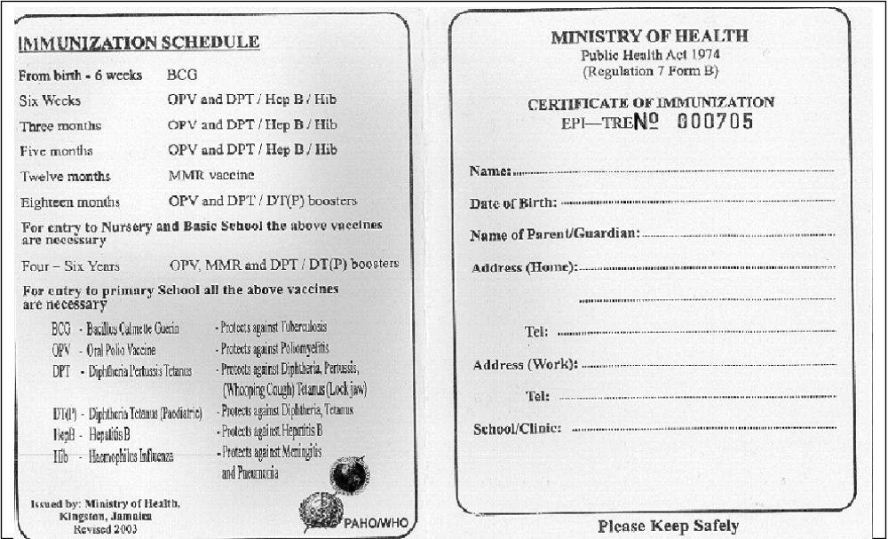
APPENDIX IV
Sample Immunization Card
Inside Section
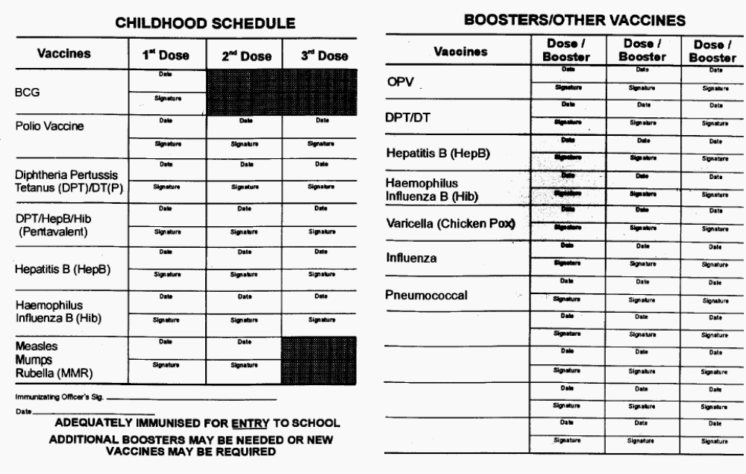
APPENDIX V

Special Medical Requirements

Child’s Name | Age | Caregiver/Teacher  Name | Chronic Illness Physical/Mental disability | Management Plan

APPENDIX V

Special Medical Requirements continued

Child’s Name | Age | Caregiver/Teacher  Name | Chronic Illness Physical/Mental disability | Management Plan

APPENDIX VI
Allergen Log

Child’s Name | Age | Caregiver/Teacher  Name | Allergen | Substitute Where Applicable

APPENDIX VII
Special Dietary Needs Log

Child’s Name | Age | Caregiver/Teacher  Name | Special Dietary Needs | Management Plan

APPENDIX VIII

Specific Parental Medication Authorization Form
(To be completed per illness or every 6 months where applicable)

Name of Child ___________________________________________________________
Date of Birth __________________ Age: ______________

Name of  Medication | Expiry Date | Dose | Time to be Given | *Method of Administration | Duration
________________
________________

________________
________________

________________
________________

________________
________________

* How it is to be given example by mouth, inhale, inhale using spacer drops to nose or mouth

Special Considerations: ____________________________________________________

________________________________________________________________________

________________________________________________________________________

To the Parent/Guardian
- All medication must:
- Be in the original container
- Over-the-counter medication must be kept in the originally labeled container and be labeled with the child's first and last name.
- Prescription medications must contain the original pharmacy label

- For long-term medication the authorization must be renewed at least once every six months.
- Any changes in the original medication authorization shall require the completion of a new authorization form.

Name of Parent: ____________________________

Signature of Parent: _________________________ Date: _____________
APPENDIX IX

Medication Log

Child’s Name | Date | Time | Name of medication | Amt. of Medication | Noticeable Adverse Reaction | Signature
APPENDIX X

Illness Log

1. Name of person affected: _____________________________________ Age: ______ Gender: _____
2. Date of Illness: ______________________________________ 4. Time of Illness: __________________
3. Description of symptoms
________________________________________________________________________________________________
______________________________________________________________________________________
______________________________________________________________________________________
5. Description of signs:
______________________________________________________________________________________
______________________________________________________________________________________
______________________________________________________________________________________
6. Actions Taken/Response of Staff
_________________________________________________________________________________________________
______________________________________________________________________________________
______________________________________________________________________________________
7. Name of Person Notified:
8. Referral
Referred by:______________________________ |  | Referred to:_________________________________________
9. Medical Practitioner’s Diagnosis
______________________________________________________________________________________
______________________________________________________________________________________
10. Form Completed by:

Name:___________________________________Signature_____________________________Date________________
APPENDIX XI
Early Childhood Institution
Injury Report Form
(To be Completed in Triplicate)
Please Print
1. Name: __________________________________________Age: _______ Gender: ___________
2. Address: __________________________________________________________________
3. Date of Injury: ___________________ 4. Time of Injury: __________________
5. Date of Reporting: ________________ 6. Reported by: __________________________
7. Institution where injury occurred: _____________________________________________
8. Category of Injured person:  Student  Employee  Parent/Guardian  Visitor
9. Where did the injury occur?
 | Nursery
 | Class Room
 | Playground
 | Kitchen
 | Other (specify): ______________________________________
10. Description of the Circumstances: (How did the injury happen)
______________________________________________________________________________
______________________________________________________________________________
______________________________________________________________________________
11. Mark the location of the injury on the diagram below.
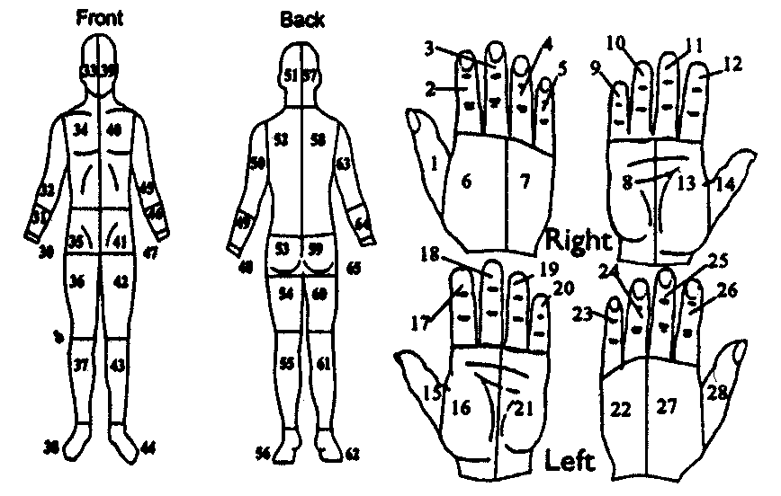
12. Was the injury: |  |  Serious
 |  |  Not Serious
 |  |  Don’t Know
13. Describe the nature of the injury: (eg. 2 inch cut to forearm; left top tooth knocked out)
______________________________________________________________________________
______________________________________________________________________________

14. Is the person injured a Child |  |  YES |  |  |  |  NO
15. If yes, Name of Employee Responsible for the Care of the Child at the time of the Injury
_____________________________________________________________________________
16. Action Taken to Treat Injury:
______________________________________________________________________________
______________________________________________________________________________
______________________________________________________________________________
______________________________________________________________________________
17. Name of Person(s) Treating Injury: _____________________________________________
18. Patient Referred to: | Physician |  |  |  |  YES |  |  NO
 | Hospital |  |  |  |  YES |  |  NO
If yes, Specify __________________________________________________________________
19. Outcome: (eg. Child admitted to hospital; treated and sent home)
______________________________________________________________________________
______________________________________________________________________________
______________________________________________________________________________
20. Parent/Guardian Notified |  YES |  |  NO | Date & Time:
21. Form Completed by:
Name: _____________________________________________
Designation: ________________________________________
Signature: __________________________________________
Date: ______________________________________________
22. Name of Institution:
Address of Institution:

APPENDIX XII
Parental Consent Form for Medical Emergency

(To be completed on Prior to the first day of admission at the Institution)

CHILD INFORMATION

Name (Last, First, MI) | Address – Home
Birth date (dd/mm/yyyy)  ________________________________________ | Date – First Day of Attendance (dd/mm/yyyy)  ____________________________________
PARENT / GUARDIAN INFORMATION Provide information where the parent(s) / guardian(s) may be reached while the child is in care.  Name  Telephone Number – Home  Telephone Number – Work  Telephone Number – Cellular | Designate INFORMATION Provide information where the adults (s) other than parents may be reached while the child is in care.  Name  Telephone Number – Home  Telephone Number – Work  Telephone Number – Cellular
PHYSICIAN / HEALTH FACILITY INFORMATION
Name of Health care Provider___________________________
Address – Medical Facility | Telephone Number
SPECIAL CONSIDERATIONS | Illness:  Medications:
I/we ___________________________________, being the parent(s)/ Guardian(S) for _______________________________________________________ hereby consent to the administration of emergency medical management deemed necessary to ensure the well being of my child.

I/ we__________________________________, further agree to be responsible for cost incurred during the emergency medical management of the same child.

Signed___________________________ signed ___________________________________________

Witness____________________________________ date ___________________________________________

APPENDIX XIII

Early Childhood Institution
Referral Form
REFFERED to:___________________________________ | Date__________________
Name of Child__________________________________ | Time _________________
Parent’s Name __________________________________ | Contact No: ___________
Name & Address of Early Childhood Institution
________________________________________________________________________

Operator’s Name ________________________________ | Contact No: __________
Name of Person accompanying :___________________________________________
Complaint:

________________________________________________________________________

Special Instructions* :_____________________________________________________

Authorized Name (please Print)__________________________________________
Signature _________________________________________

* E.g. child to be met at facility by parents/ Child to return to facility with care giver
APPENDIX XIV

Early Childhood Institution
First Aid Kit Checklist
Name of designated employee: ______________________________________ Year:___________.

This first aid kit will be checked on the first working day of each month. Items to be re-stocked must be brought to the attention of the operator by the designated employee.

 | Jan | Feb | Mar | Apr | May | Jun | Jul | Aug | Sep | Oct | Nov | Dec
adhesive strips / band aids
adhesive tape
eye pads
triangular bandages
conforming bandages
safety pins
scissors
tweezers
kidney dish
disposable gloves
gauze squares/ pads
Alcohol swabs
sterile saline eyewash
Cold pack
plastic bags
Antiseptic ointment
reusable ice pack
Hand cleanser
Small Flashlight and Extra Batteries
Blanket

APPENDIX XV

Sick Bay Register
Name of Child | Date & Time Admitted | Reason Child Admitted | Treatment Administered
APPENDIX XV

Sick Bay Register (Continue)

Medication Administered | How Child leaves | Time Child Leaves | Signature of Staff on Duty

APPENDIX XVI
Maintenance of Cleaning Schedule for Environmental areas

CLEANING SCHEDULE

ITEM/AREA TO BE CLEANED | PERSON RESPONSIBLE | FREQUENCY OF CLEANING | CLEANER | SANITIZER | SUPERVISOR’S INITIALS
APPENDIX XVII
REFRIGERATOR STORAGE/HOLDING CHECK LIST

Proper storage of food and the efficient operation of cold storage units with
regular temperature monitoring and recording prevents food – borne illnesses



